**Disciplined Entrepreneurship Workbook**

# Step 15: Design a Business Model

**Worksheet:**

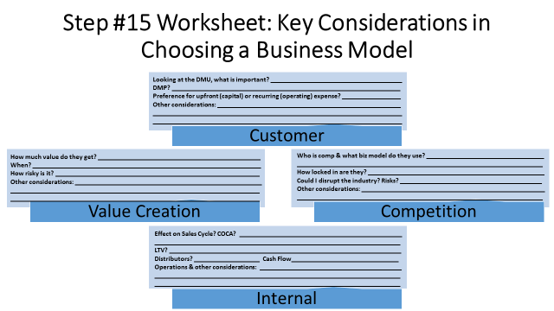

##### **Customer**

* **Looking at the DMU, what is important?** Achieving research impact, efficiency, and justifying budget use are key priorities for the DMU.
* **DMP?** The Decision Making Process involves end-user/champion advocacy and economic buyer approval, often navigating institutional procurement.
* **Preference for upfront (capital) or recurring (operating) expense?** Researchers and institutions generally prefer predictable recurring operating expenses for software subscriptions.
* **Other considerations:** Budget constraints within academic labs necessitate clear ROI justification for new expenditures. Procurement processes in universities can be lengthy and require specific documentation for approval.

##### **Value Creation**

* **How much value do they get?** Users get significant value through a 50% reduction in research cycle time and enhanced research quality.
* **When?** Value is delivered continuously throughout the research lifecycle as tasks are automated and insights are generated.
* **How risky is it?** Adoption risk exists related to trusting AI outputs, requiring validation and user control features.
* **Other considerations:** The value proposition strongly aligns with core researcher priorities like academic excellence and innovation. The self-improving nature of the AI means the value delivered increases over time for the customer.

##### **Competition**

* **Who is comp & what biz model do they use?** Competitors like Google's Co-Scientist, Sakana, and OpenAI DeepResearch likely use subscription or usage-based cloud models.
* **How locked in are they?** Customers currently use fragmented tools, suggesting low lock-in to any single integrated solution currently.
* **Could I disrupt the industry? Risks?** Yes, the self-improving core offers disruption potential; risks include adoption hurdles and proving reliability.
* **Other considerations:** Our Core (self-improving AI) provides a key differentiator against competitors with static systems. Our competitive positioning aims for superiority in both research acceleration and quality enhancement.

##### **Internal**

* **Effect on Sales Cycle? COCA?** The sales cycle is estimated at 6-22 weeks, with COCA initially lower via digital means but increasing for enterprise.
* **LTV?** Cash Flow Recurring revenue (€250-€1000/user/year initially) supports predictable LTV and stable cash flow via subscriptions.
* **Distributors?** Initial sales are direct, but institutional resellers could become a channel later.
* **Operations & other considerations**: Operations involve digital delivery, requiring investment in R&D for AI improvements and customer support. Managing cloud infrastructure costs and ensuring scalability are important operational factors.

**Identification of Different Units of Product You Can Charge For (if appropriate)**

What are the different potential units you could charge for? (e.g., individual product, number of users, usage, site license, etc.)

1. **Per Named User Seat**:   
   **Pros:** Simple, predictable revenue, common in SaaS   
   **Cons**: Can be costly for large labs, friction in adding users.
2. **Usage-Based (e.g., compute hours, API calls, tokens consumed):**   
   **Pros**: Scales directly with value/usage, potentially lower entry cost.  
   **Cons:** Unpredictable costs for users, harder to budget, complex tracking.
3. **Institutional Site License (e.g., University Department, Lab Group):**   
   **Pros:** Easier for large organizations to purchase, predictable cost for buyer, larger deal size.   
   **Cons:** Longer sales cycle, requires clear definition of "site", may undervalue heavy users.

|  |  |  |  |  |  |  |  |  |  |
| --- | --- | --- | --- | --- | --- | --- | --- | --- | --- |
| **Summary of Business Model Candidates** | | | | | | | | | |
| **#** | **Option** | **Unit** | **Cust. Fit** | **Value Creation Fit** | **Comp.**  **Fit** | **Internal Fit** | **Pros** | **Cons** | **Grade** |
| 1 | **Subscription per User (Tiered)** | Named User | High | High | High | High | Predictable revenue, simple, aligns with SaaS norms, allows tiers. | Can get expensive for large teams, potential for seat sharing. | A |
| 2 | **Freemium (Limited Use Free Tier)** | User / Usage | High | Medium | Medium | Medium | Lowers adoption barrier, good for lead gen, potential virality. | Conversion challenges, cost of free users, potential value perception hit. | B |
| 3 | **Usage-Based Subscription** | Compute/Tokens/etc | Medium | High | Medium | Medium | Aligns cost with value, flexible for users with variable needs. | Unpredictable costs, harder to budget, complex metering/billing. | B- |
| 4 | **Institutional Site License (Tiered)** | Department/Lab | High | High | Medium | Medium | Good for large buyers, predictable cost, simplifies procurement. | Longer sales cycle, complex pricing tiers, needs clear definitions. | A- |
| 5 | **Hybrid (Base User Fee + Usage)** | User + Usage | Medium | High | Medium | Low | Captures base value & scales with usage, flexible. | Complex for customer to understand, complex billing/tracking internally. | C+ |

1. **Initial Decision and Rationale**

Which business model did you choose and why?

We choose a **Tiered Subscription per User** model (Option #1) as the initial primary business model. This model offers predictability for both customers and Cogency AI, aligns well with standard academic/SaaS purchasing preferences for operational expenses, and is simple to understand and administer. Tiering allows flexibility to capture different value levels (e.g., basic features vs. advanced agent controls) and supports scaling from individual researchers to small teams, directly aligning with our beachhead market approach and value proposition.

**2. Tests to Validate**

* 1. What hypotheses are you assuming to be true for the business model(s) you have chosen?  
       
     We assume researchers/labs are willing to pay €250-€1000 per user annually for significant research acceleration, and they prefer predictable per-user subscriptions over usage-based uncertainty.
  2. What experiments will you run to test your hypotheses?   
       
     We will offer distinct subscription tiers during beta/early access programs with varying features and price points, and monitor signup rates and tier selection for each.
  3. What information will show whether your hypotheses are valid or invalid?  
       
     Conversion rates for paid tiers, distribution of users across tiers, direct feedback on pricing fairness, and comparison of revenue per user against TAM estimates will validate/invalidate hypotheses.
  4. How long will you give the experiments to run?  
       
     We will run these pricing experiments for the first 3-6 months post-launch or during the initial beta program to gather sufficient data on user preferences and willingness to pay.